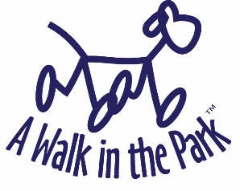
ACH Payment Authorization

Client Name: __________________________________________________________
Account Holder Name: __________________________________________________________
Relationship to Client: Self _____________ Relative (specify)___________________________
Bank Routing Number: __________________________________________________________
Account Number: __________________________________________________________
Billing Address: __________________________________________________________
(include Zip Code) __________________________________________________________
Phone Number: __________________________________________________________
I certify that I am an authorized user of the above bank account. I agree to allow Kare 4 Kritters, Inc. (doing business as A Walk in the Park) to initiate an ACH transaction on an on-going basis for pet care services provided for the client named above. I understand that an ACH processing fee will be added to each invoice and paid via the ACH transaction. The current ACH processing fee is 1.30% of the total bill + $0.30.

I understand that I may cancel ACH payments at any time by contacting Kare 4 Kritters, Inc./A Walk in the Park. I acknowledge that unless I request that automatic ACH payments be stopped, Kare 4 Kritters, Inc./A Walk in the Park will process my ACH payments following the completion of all services listed on an invoice.

Cardholder Signature: ________________________________ Date: ___________________

